# Car Accident Severity

# 

1.Introduction:

1.1 Background:

Road Accident is the most undesirable and unexpected thing to occur to a road user, though they happen quite often. Unfortunately, we can see a minatory rise of road accidents , conspicuously highroad accidents over the past few years. It has a massive impact on society as well as in the economy of our country as there is an immense cost of fatalities and injuries.

1.2 Problem:

In an effort to reduce the frequency of car collisions in a community, an algorithm must be developed to predict the severity of an accident given the current weather, road and visibility conditions. When conditions are bad, this model will alert drivers to remind them to be more careful.

1.3 Interest:

Obviously, every person driving from one city to other or driving back home from work would be interested in weather and the road conditions about the possibility of you getting into a car accident and how severe it would be, so that you would drive more carefully or even change your travel if you are able to

## Data Understanding:

Our predictor or target variable will be 'SEVERITYCODE' because it is used measure the severity of an accident from 0 to 5 within the dataset. Attributes used to weigh the severity of an accident are 'WEATHER', 'ROADCOND’, 'LIGHTCOND',’ The total number of people involved in the collision’ and’ The number of vehicles involved in the collision.

Severity codes are as follows:

|  |  |
| --- | --- |
| 0 | Little to no Probability (Clear Conditions) |
| 1 | Very Low Probability - Chance or Property Damage |
| 2 | Low Probability - Chance of Injury |
| 3 | Mild Probability - Chance of Serious Injury |
| 4 | High Probability - Chance of Fatality |

There are three types of machine learning algorithms supervised ,unsupervised learning, and reinforcement learning . Among these three broad categories of machine learning classification approaches the supervised learning approach is used because of its competency in modelling and regulating dynamic systems. Here, I used the four most popular machine learning techniques for car accident severity. Those are Decision Tree, KNN, SVM, Logistic Regression.

### 2. Data Pre-Processing:

In it's original form, this data is not fit for analysis. For one, there are many columns that we will not use for this model. Also, most of the features are of type object, when they should be numerical type.

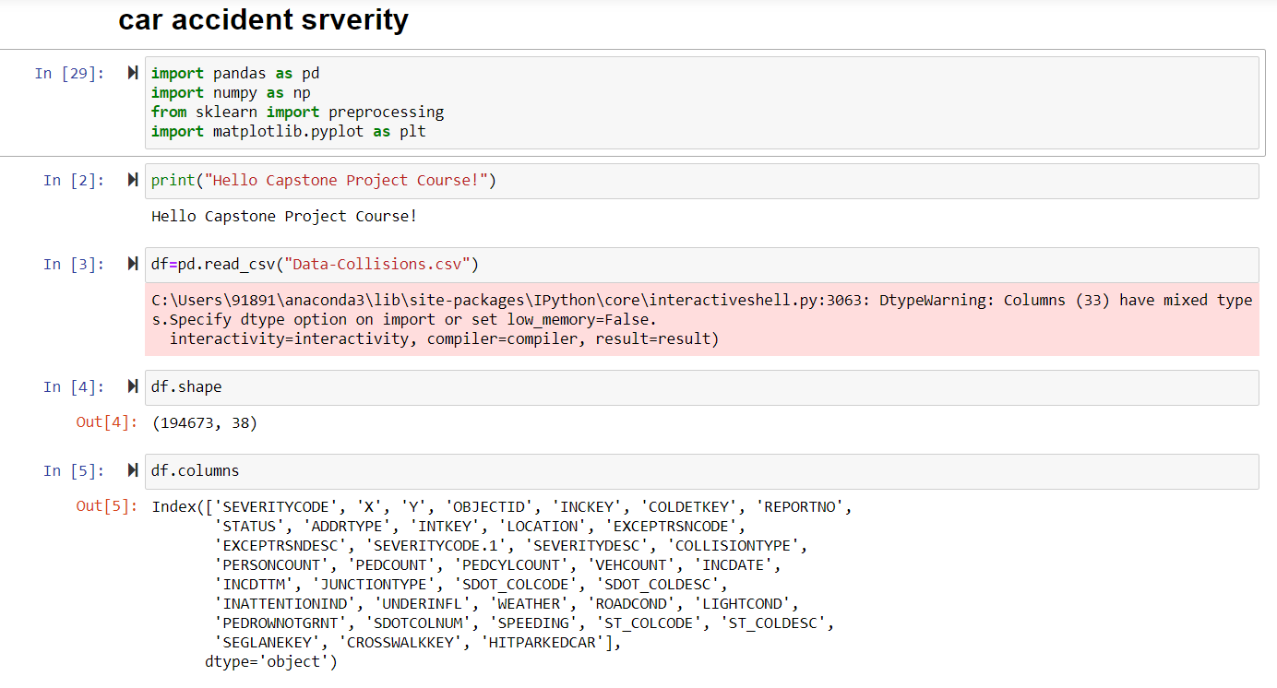

# 2.1 Missing Data:

Missing Data can occur when no information is provided for one or more items or for a whole unit. Missing Data is a very big problem in real life scenario. Missing Data can also refer to as NA(Not Available) values in pandas. In Data Frame sometimes many datasets simply arrive with missing data, either because it exists and was not collected or it never existed. For Example, Suppose different user being surveyed may choose not to share their income, some user may choose not to share the address in this way many datasets went missing.

In Pandas missing data is represented by two value:

* None: None is a Python singleton object that is often used for missing data in Python code.
* Nan : Nan (an acronym for Not a Number), is a special floating-point value recognized by all systems that use the standard IEEE floating-point representation

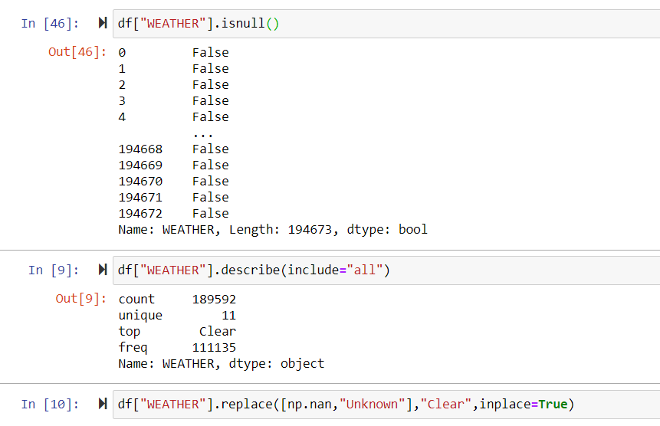

2.2 Encoding:

We must use label encoding to covert the features to our desired data type. **Label Encoding** refers to converting the labels into numeric form so as to convert it into the machine-readable form. Machine learning algorithms can then decide in a better way on how those labels must be operated. It is an important pre-processing step for the structured dataset in supervised learning.

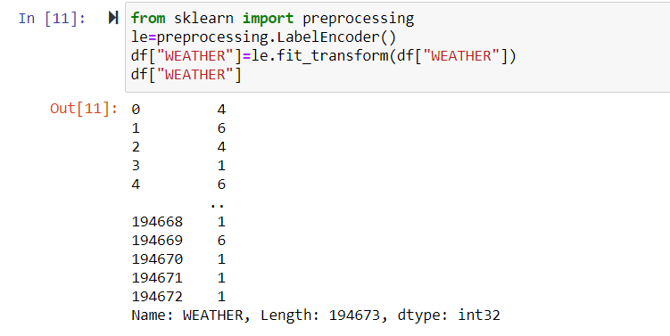

2.3 Feature Scaling

Feature Scaling is a technique to standardize the independent features present in the data in a fixed range. It is performed during the data pre-processing to handle highly varying magnitudes or values or units. If feature scaling is not done, then a machine learning algorithm tends to weigh greater values, higher and consider smaller values as the lower values, regardless of the unit of the values.

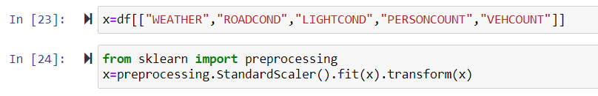

# 2.4 Training Data and Test Data:

Training data and test data are two important concepts in machine learning. This chapter discusses them in detail.

## Training Data:

The observations in the training set form the experience that the algorithm uses to learn. In supervised learning problems, each observation consists of an observed output variable and one or more observed input variables.

## Test Data:

The test set is a set of observations used to evaluate the performance of the model using some performance metric. It is important that no observations from the training set are included in the test set. If the test set does contain examples from the training set, it will be difficult to assess whether the algorithm has learned to generalize from the training set or has simply memorized it.

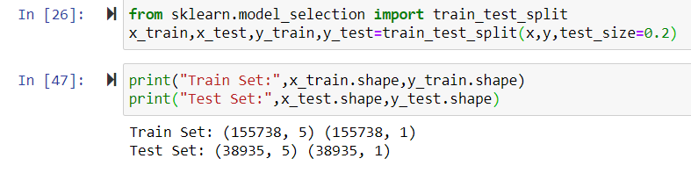

3. Predictive Modelling:

3.1 K-nearest neighbours (KNN):

K-nearest neighbours (KNN) algorithm is a type of supervised ML algorithm which can be used for both classification as well as regression predictive problems. However, it is mainly used for classification predictive problems in industry. The following two properties would define KNN well −

* **Lazy learning algorithm** − KNN is a lazy learning algorithm because it does not have a specialized training phase and uses all the data for training while classification.
* **Non-parametric learning algorithm** − KNN is also a non-parametric learning algorithm because it doesn’t assume anything about the underlying data.

## Working of KNN Algorithm:

K-nearest neighbors (KNN) algorithm uses ‘feature similarity’ to predict the values of new datapoints which further means that the new data point will be assigned a value based on how closely it matches the points in the training set. We can understand its working with the help of following steps −

**Step 1** − For implementing any algorithm, we need dataset. So during the first step of KNN, we must load the training as well as test data.

**Step 2** − Next, we need to choose the value of K i.e. the nearest data points. K can be any integer.

**Step 3** − For each point in the test data do the following −

* **3.1** − Calculate the distance between test data and each row of training data with the help of any of the method namely: Euclidean, Manhattan or Hamming distance. The most commonly used method to calculate distance is Euclidean.
* **3.2** − Now, based on the distance value, sort them in ascending order.
* **3.3** − Next, it will choose the top K rows from the sorted array.
* **3.4** − Now, it will assign a class to the test point based on most frequent class of these rows.

**Step 4** – End

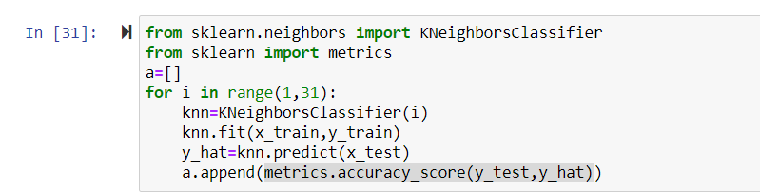

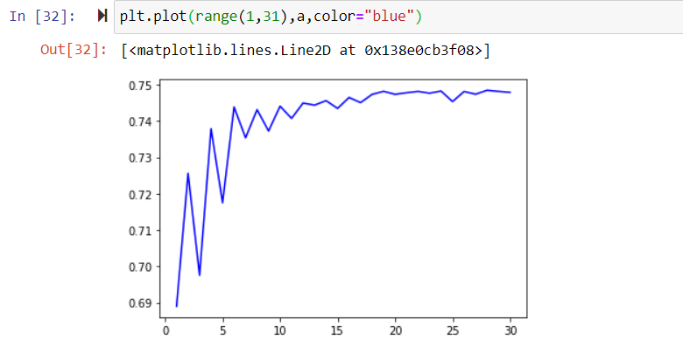

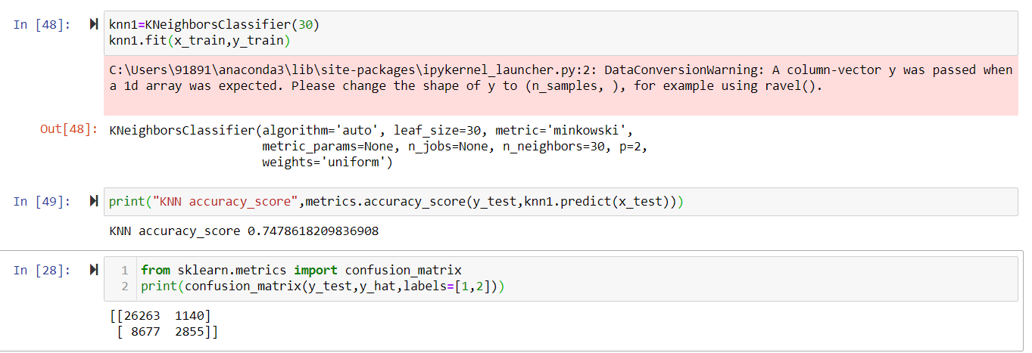

## 3.2 Decision Tree:

In general, Decision tree analysis is a predictive modelling tool that can be applied across many areas. Decision trees can be constructed by an algorithmic approach that can split the dataset in different ways based on different conditions. Decisions tress are the most powerful algorithms that falls under the category of supervised algorithms.

They can be used for both classification and regression tasks. The two main entities of a tree are decision nodes, where the data is split and leaves, where we got outcome. The example of a binary tree for predicting whether a person is fit or unfit providing various information like age, eating habits and exercise habits

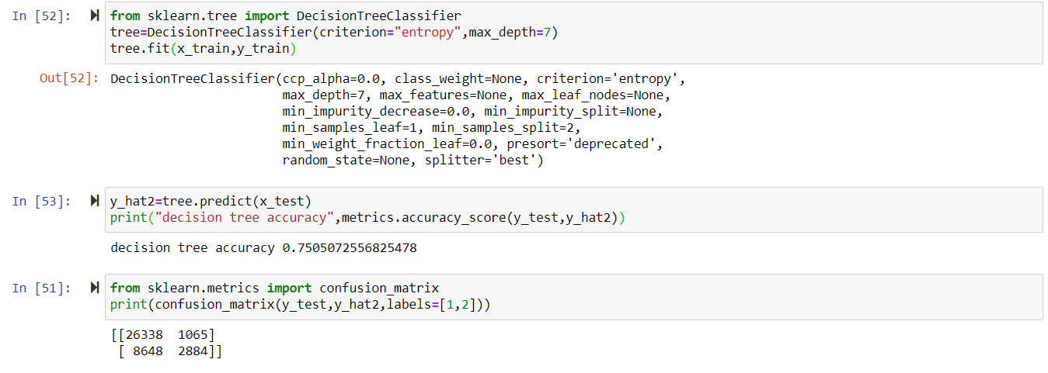

## 3.3 Logistic Regression:

Logistic regression is a supervised learning classification algorithm used to predict the probability of a target variable. The nature of target or dependent variable is dichotomous, which means there would be only two possible classes.

In simple words, the dependent variable is binary in nature having data coded as either 1 (stands for success/yes) or 0 (stands for failure/no).

Mathematically, a logistic regression model predicts P(Y=1) as a function of X. It is one of the simplest ML algorithms that can be used for various classification problems such as spam detection, Diabetes prediction, cancer detection etc.

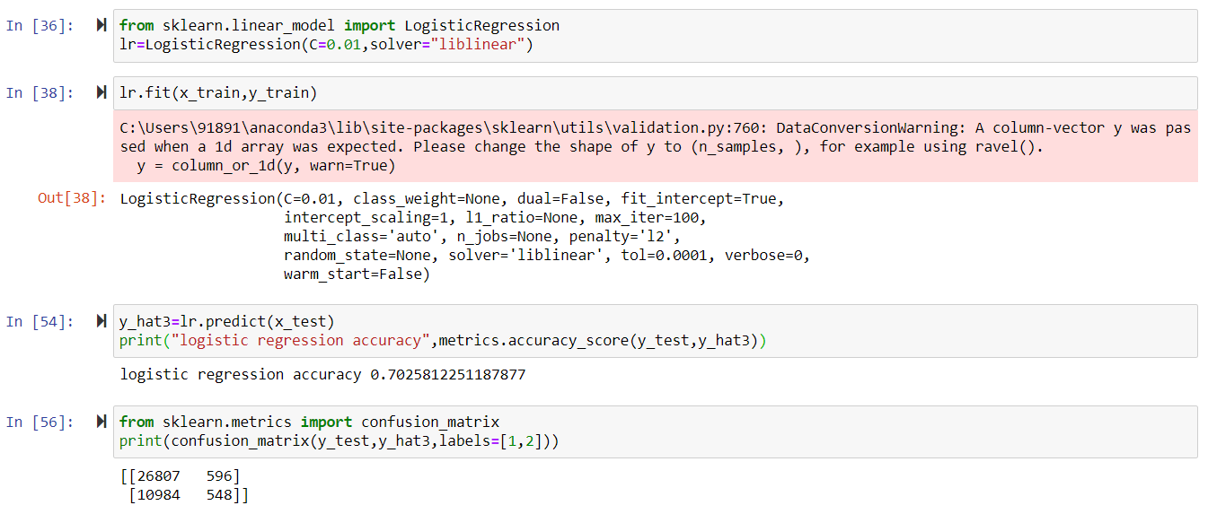

## 3.4 SVM:

Support vector machines (SVMs) are powerful yet flexible supervised machine learning algorithms which are used both for classification and regression. But generally, they are used in classification problems. In 1960s, SVMs were first introduced but later they got refined in 1990. SVMs have their unique way of implementation as compared to other machine learning algorithms. Lately, they are extremely popular because of their ability to handle multiple continuous and categorical variables.

An SVM model is basically a representation of different classes in a hyperplane in multidimensional space. The hyperplane will be generated in an iterative manner by SVM so that the error can be minimized. The goal of SVM is to divide the datasets into classes to find a maximum marginal hyperplane (MMH).

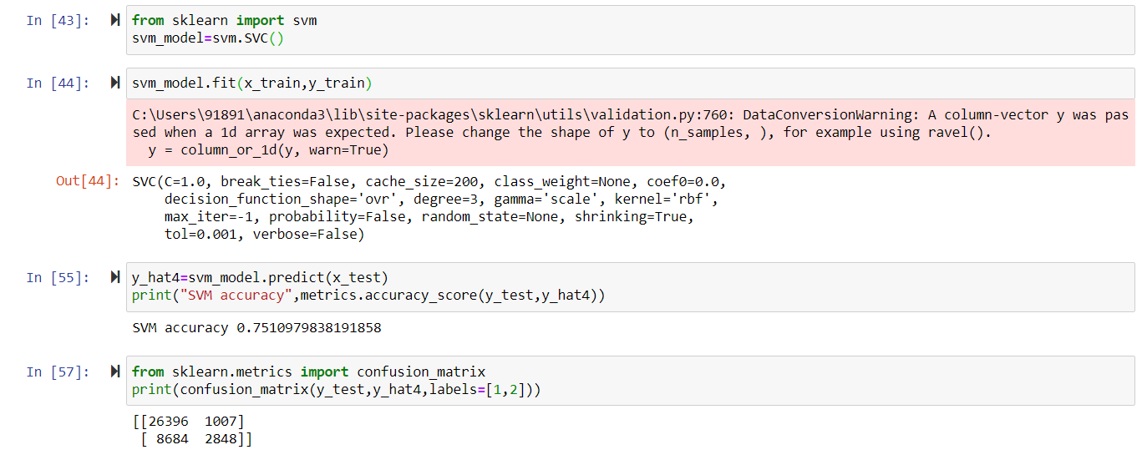

# Results and Evaluations

The final results of the model evaluations are summarized in the following table:

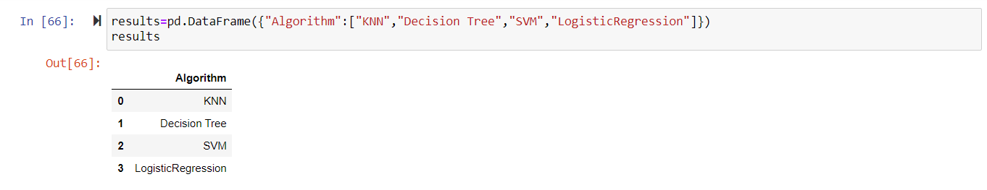

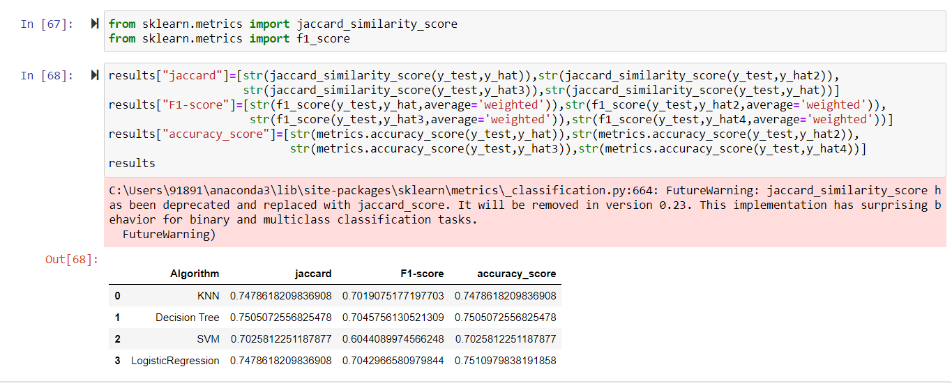

## Conclusion

Based on historical data from weather conditions pointing to certain classes, we can conclude that particular weather conditions have a somewhat impact on whether or not travel could result in property damage (class 1) or injury (class 2).In terms of accuracy of SVM model and Decision Tree model are better but in terms of speed Logistic Regression is better